**Develop The Web Application Using**

**Node-RED**

**TEAM ID:** **PNT2022TMID50776**

Aim: Develop the web application using Node-RED Steps Followed:

* Opened a Node-RED project

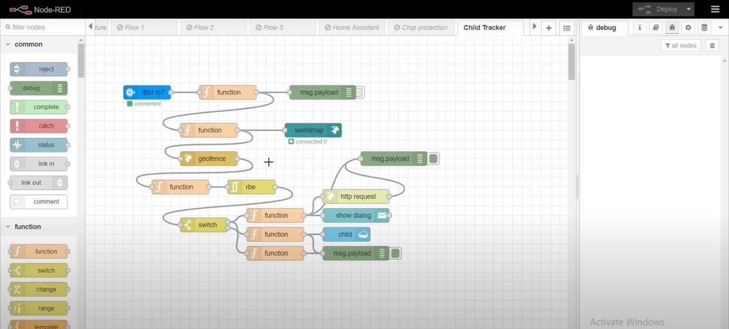

* Added code to get child location in python

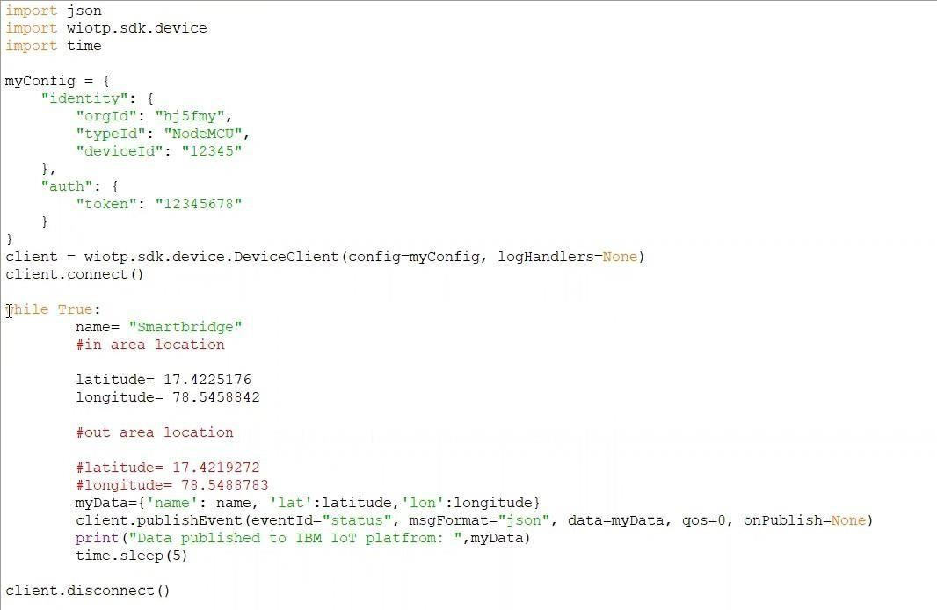

Created the GeoFence

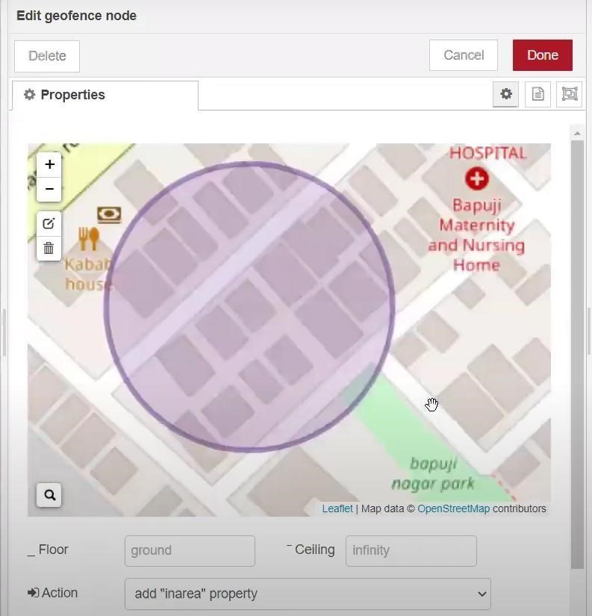

Editing the HTTP Request URL

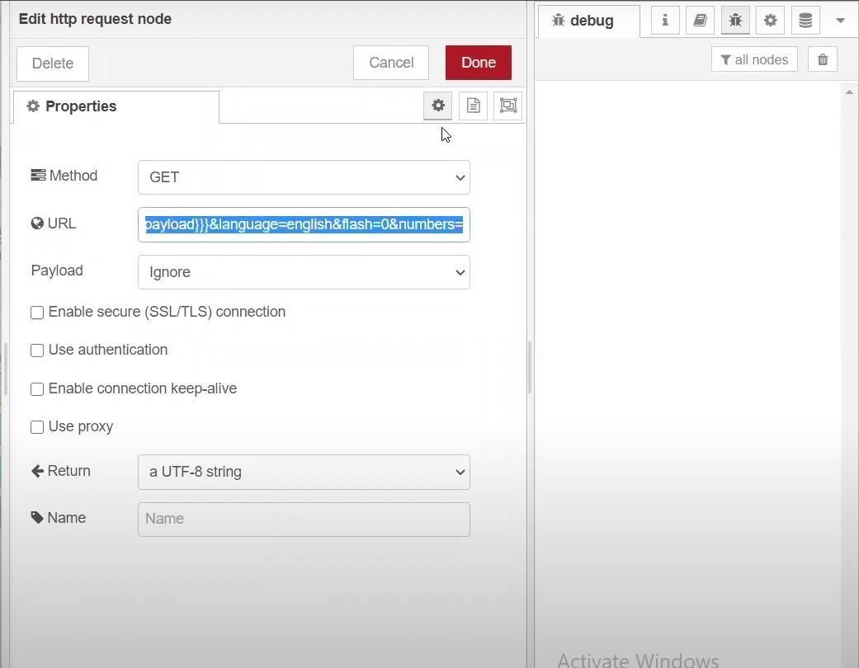

* Located the child

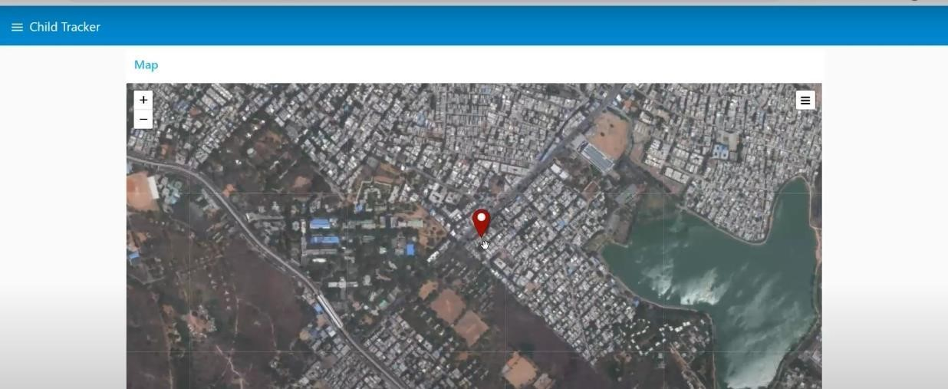

Created the geofence node

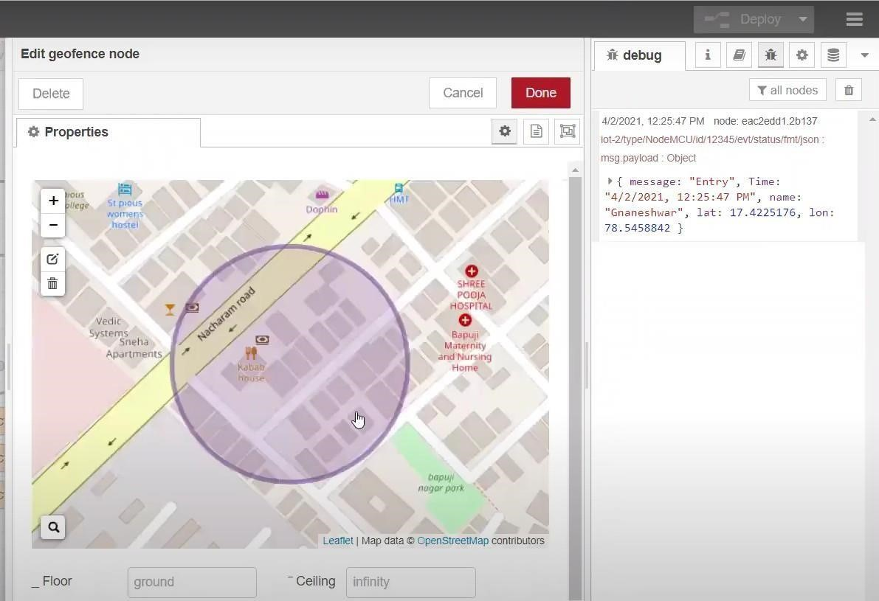

* Python script sending requests to IBM Cloud

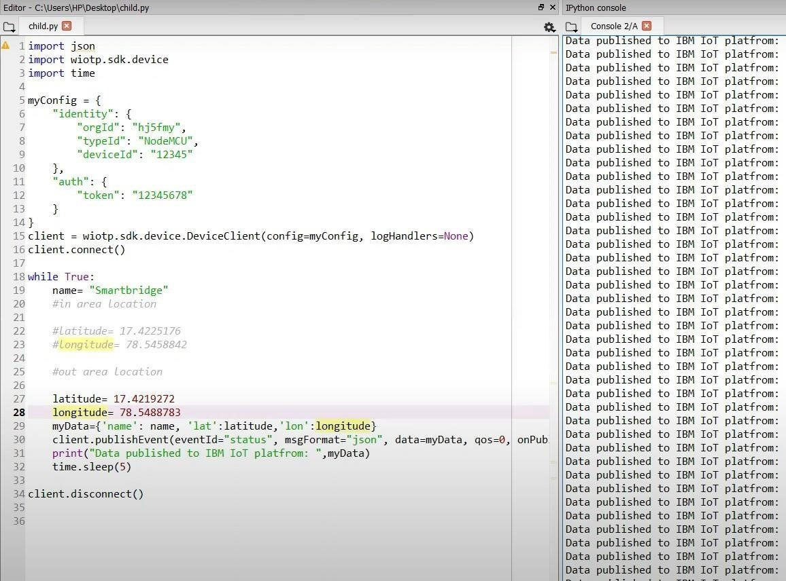

After running the script, the web UI shows “Person is not in the particular area”

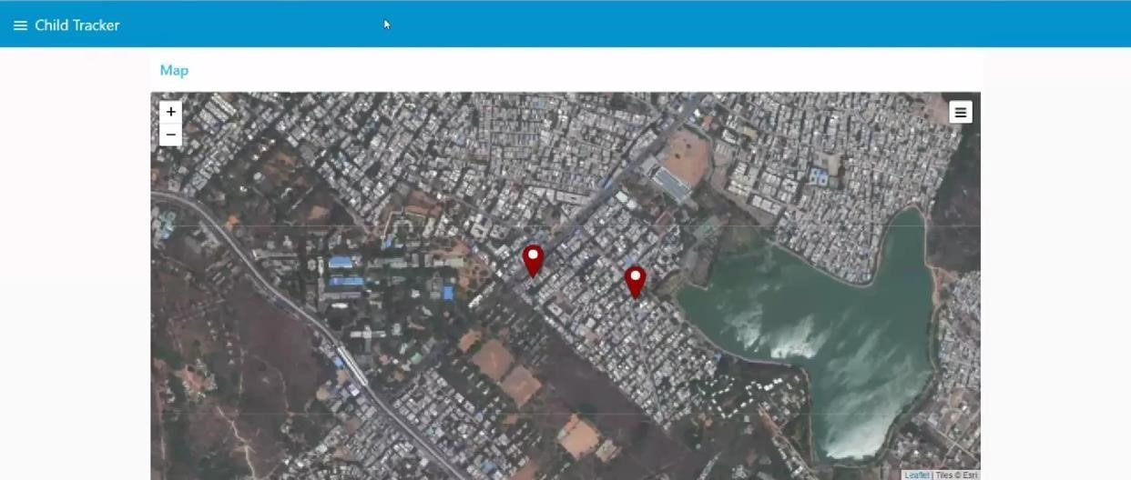

Result: Successfully developed the web application using Node-RED